**TECHNICAL REPORT ON STUDENTS INDUSTRIAL WORK EXPERIENCE SCHEME (SIWES)**

**AT**

**Stechmax LTD,**

**OBUDU, CROSS RIVER STATE**

**FROM: 4TH JANUARY, 2023**

**TO:4TH MAY, 2023**

**BY**

**DENILSON MOBRE NICHOLAS**

**ST/CS/ND/21/094**

**SUBMITTED TO THE DEPARTMENT OF COMPUTER SCIENCE, SCHOOL OF SCIENCE AND TECHNOLOGY, IN PARTIAL FULFILLMENT OF THE REQUIREMENT FOR THE AWARD OF NATIONAL DIPLOMA (ND), COMPUTER SCIENCE, FEDERAL POLYTECHNIC, MUBI, ADAMAWA STATE.**

**JUNE, 2023**

**DEDICATION**

I dedicate this technical report to my lovely parents who gave me all the support and care throughout my SIWES program.

# ACKNOWLEDGMENTS

I thank God Almighty for making me to undergo students industrial work experience scheme (SIWES) successfully.

My gratitude goes to my parent for their prayers, financial and moral support during my attachment.

I also appreciate the kind gesture of my brothers and sisters and those who supports me in prayers and contribution during my industrial attachment.

I whole heartedly thank my Head of department Mallam Adamu Garba Mubi, SIWES coordinator and all lectures of Computer Science for their effort to ensure my success as their students.

I am greatly indebted to my co-SIWES students to mention, may God strengthen our relationship together and grant us academic excellence.

I sincerely thank you all for your contribution and support.

**ABSTRACT**

*The report summarises the result of work done during my SIWES experience, the technical report consists of four chapters, which comprises of introduction, history and criteria’s of SIWES in chapter one followed by their aims and objectives, historical background, organizational structure of the organization in chapter two, while chapter three consist of the work actually carried out during the SIWES programme and lastly chapter four consist of the summary, conclusions and recommendation.*

**TABLE OF CONTENTS**

TITLE PAGE - - - - - - - - - i

DEDICATION - - - - - - - - ii

ACKNOLEDGEMENTS - - - - - - - iii

ABSTRACT - - - - - - - - - iv

**CHAPTER ONE**

1.0INTRODUCTION - - - - - - - - 1

1.1 THE NEED FOR SIWES - - - - - - - 1

1.2 DEFINITION OF SIWES - - - - - - - 1

1.3 AIMS AND OBEJECTIVE OF SIWES - - - - - 2

1.4 BRIEF HISTORY OF SIWES - - - - - - 2

1.5 THE SIGNIFICANT OF SIWES TO STUDENT - - - 2

**CHAPTER TWO**

2.1 BRIEF HISTORY OF THE ORGANIZATION - - - - 4

2.2 ORGANIZATIONAL CHART - - - - - - 4

**CHAPTER THREE**

**EXPERIENCE GAINED DURING THE INDUSTRIAL TRAINING**

3.1 INTRODUCTION TO COMPUTER - - - - - 5

3.2 INTRODUCTION TO MICROSOFT WORD - - - - 8

3.3 INTRODUCTION TO COREL DRAW - - - - - 10

3.4 MICROSOFT POWERPOINT - - - - - - 16

**CHAPTER FOUR**

4.1 SUMMARY - - - - - - - - 22

4.2 CONCLUSION - - - - - - - - 22

4.3 PROBLEMS OBSERVED DURING MY PROGRAM - - - 23

4.4 RECOMMENDATION - - - - - - - 23

REFERENCE - - - - - - - - - 24

**CHAPTER ONE**

1. **INTRODUCTION.**

The acronym (SIWES) stands “student industrial work experience Scheme” is a practical training program designed to offer students the example opportunity to use the best equipment with the Practical aspect of their development knowledge. The training Which lasted for four (4) month was necessity to all student in institutions of higher learning most importantly to those in Polytechnic, universities of technology as it forms part of higher National diploma, bachelor degree in science and technology. It Familiar in handling equipment, curial work methods of end of the Training so that upon graduation he/she is practically fit for jobs Relevant to his/her discipline.

**1.1 THE NEED FOR SIWES**

The Federal Government designed this program as a result of Wide range gap that has existed between the theory and practical of All practical gifted courses in Science and Technology, Engineering Management and other professional education program in Nigerian institution of higher leading, it is for this reason that Federal Government in collaboration with the national board for technical education (NABTE) and Nigeria board of universities commission(NUO) made it necessary for all student in Nigeria institutions to Undergo the training for some period with reputable organization that match their disciplines so to satisfy the polytechnic or universities required standard from the student.

**1.2 DEFINATION OF SIWES**

The student’s industrial work experience scheme (SIWES): is a skill training program designed to expose and prepare student in the institution of higher learning for industrial working station that they may likely meet or face after graduation. The scheme is also meet to expose student to work methods and give them the needed experience in handling equipment and machinery they may not be available in high institution.

**1.3 AIM AND OBJECTIVE OF SIWES**

1. To developed student practical knowledge in the perspective field of studies
2. To create job opportunity for student after their graduation or after the completion of their school.
3. To create an avenue for student to shared their idea and skills with other people in the society.
4. It is mean of destiny, career, goals and provision of work experience prior graduation.
5. To create the gap between skills and unskilled people in the society.
6. To expose and prepare student situation outside the academic environment.

**1.4 BRIEF HISTORY OF SIWES.**

Under the leadership of Gen Yakubu Gowon the industrial training fund (I.T.F) was established under the decree No 14 in October 1971. The major objectives of establishing this program is to promote good number of indigenous trained of man power that is sufficient to meet up with Nigeria three years of programmer and made to equip student with practical of what has been taught theoretically in school. The shame is meant to equip student with method of handling equipment and facilities that may not be available in the institution. This programmer being funded by government of Nigeria was made effective through the industrial training fund (I.T.F) board started in 1974 with their headquarters in Jos plateau state.

**1.5 THE SIGNFICANT OF SIWES TO STUDENT**

1. Principles taught in class room are vein forced and given concert application on industrial assignment and student are able to see the relevant of their studies which increase their motivation.
2. It make a student to have a clear picture of their career prospect and better understanding of the word work as socio-economic system and wading to horizon and adjustment of social of passage of time but due part of the excursion into a largely adult environment.
3. Student gain confidence as a result of successful assignment with profitable feedback to their academic student to enhance reliance of their attachment.
4. It cause student to add value, and assist in developing skills in the application of theory, the principle concepts to the real problem and period of technical training vocabulary.

**CHAPTER TWO**

**2.1 BRIEF HISTORY OF Stechmax LTD**

Stechmax LTD, formerly known as Success Computers, is a company that has been in operation since 2014. Our journey began under the name Success Computers, and we have since rebranded ourselves as Stechmax LTD.

At Stechmax, we are committed to providing innovative solutions and top-quality services to our valued clients. With years of experience in the industry, we have built a reputation for excellence and reliability. Our team of skilled professionals works diligently to stay ahead of the rapidly evolving technology landscape, ensuring that we offer cutting-edge solutions tailored to meet the unique needs of our customers. We take pride in our ability to adapt to market trends and deliver results that exceed expectations. Our dedication to customer satisfaction has been a driving force behind our success. We strive to foster long-lasting relationships with our clients, understanding their specific requirements and providing them with personalized solutions that drive growth and success.

As a company, we understand the importance of staying updated with the latest advancements in technology. This enables us to offer a wide range of services, including software development, IT consulting, network solutions, and much more. We are continuously expanding our expertise and exploring new avenues to provide our clients with comprehensive and innovative solutions.

At Stechmax, we believe in the power of collaboration and partnership. By working closely with our clients, we ensure that our solutions align with their goals and objectives. We value transparency, integrity, and professionalism in all our interactions, striving to build trust and exceed expectations at every step.

**2.2 ORGANIZATIONAL CHART**

Figure1: Organizational Chart

**CHAPTER THREE**

**EXPERIENCE GAINED DURING THE STUDENT INDUSTRIAL WORKING EXPERIENCE (SIWES)**

**3.1 INTRODUCTION TO COMPUTER**

A computer system be it micro, main frame or super computer consist of both software and hardware, it is an electronic machine capable of accepting data and process the data into a meaningful information as an output.

A computer is a machine or tool which is capable of

1. Taking input data
2. Storing the input data
3. Processing the input data
4. Producing the output reports on paper or computer store for future.

The term computer is obtained from the word compute. A computer is an electronic device that input (take in) fact(data)and then process(manipulate) storing (saving) output (information).

**3.1.2 INFORMATION TECHNOLOGY**

In simple language information technology (IT) refers to the development, maintenance, and use of computer software, system and networks. It includes their use for processing and distribution of data. Data means information’s, facts statistics, etc, gathered together for reference, storage or analysis.

Information technology is the design and implementation of computer networks for data processing and communication.

This include designing the hardware for processing information and connecting separate components, and developing software that can efficiently and faultlessly analyze and distribute this data.

**3.1.3 PART OF COMPUTER SYSTEM**

There are two main part of computer Hardware and software

**HARDWARE**

This are all part of the computer which you can see and touch. Computer hardware is the collection of physical parts of a computer system. This includes the computer case such monitor, keyboard and mouse it includes all the parts insides the computer case, such as the hard disk drive, mother board video card and many other.

There are five main hardware components in a computer system.

1. Input
2. Processing
3. Storage
4. Output
5. Communication

**INPUT AND OUTPUT DEVICES**

An input device sends information to a computer system for processing, and an output device reproduces or displays the results of that processing.

Input devices only allows for input of data to a computer and out devices only receives the output of data from another devices.

**Input devices list**

1. Graphic tablets
2. Camera
3. Video capture Hardware
4. Keyboards
5. Scanner
6. Webcam
7. Microphone
8. Electronic white board

**Output devices list**

1. Monitor (LED, LCD, CRT etc)
2. Printers (all type)
3. Projector
4. LCD Projection Panels
5. Head Phones
6. Film Recorder
7. Visual display Unit
8. Speakers

**SOFTWARE**

The software have physical presence, they are stored in digital forms within computer memory. There are different categories of software, including the system software, utilities software and applications software.

1. System software
2. Utility software
3. Application software

**SYSTEM SOFTWARE**

This is the software used to manage and control the hardware components and which allows interaction between the hardware and other types of software. The most obvious types of software is the computer operating system but device driver is are also included within this categories

**UTILITY SOFTWARE**

This is the software such as anti-virus software, firewalls, disk defragmenters and so on which helps to maintain and protect the interface with the hardware.

**APPLICATIONS SOFTWARE**

This are designed to allow the user of the system complete a specific task or set of tasks. They includes programs such as web browsers, office software, games and so on. They are usually the reason you bought the computer system in the first place and they are unconcerned with the management of the system itself

**3.2 COMPUTER REPAIRS AND MAINTENANCE TOOLS**

To accurately and easily troubleshoot a system, a computer engineering needs to possess all the basic tools required for computer maintenance and other relevant tools also. But first proper precautions should be taking like;

Some of these tools include;

1. Putting all component to be worked on, on an insulated table
2. Always be careful of other close component
3. Do not work on a live board.

**3.2.1**  **HARDWARE TOOLS**

1. **Anti-static wrist band:** The computer is made up of some of components that require very little electric charges to operate. The static electricity in the body may be far greater than the required charge, thus the destruction of such component. The anti-static wrist strap is used to prevent static electricity charges from destroying the computer parts by grounding your body. The metal clip is connected to a bare metal part of the computer case like the metal case of a PC.
2. **Tweezers:** It is a too; used for picking up and manipulating objects too small to be handled with the human hand.
3. **Long Nose Plier**: It used to cut wires and can get in and out of tight spots, unlike regular pliers.
4. **Soldering Iron**: It is essential for repairs on mother board but with extreme care. When used carelessly, it can destroy the board as well as injure the engineer.
5. **8” Wire Cutter/ Stripper**: It is for wire cutting and stripping insulation on a single, multiple, fine stranded of wire cables with plastic or rubber insulation.
6. **Hot air blower/Rework Station:** This is used in desoldering parts that are faulty or have been being wrongly soldered. It weakens the lead. It is also used in the application of paste (heat dependent gum) on board.
7. **Set of Screw Drivers:** The different parts of the computer are made of nuts and screws of different sizes, thus the need for multi-mouth screw driver set. It is used in the loosening of nuts and screws.
8. **Paste flux:** This is a heat dependent non-insulating joining paste used to attach components on the board.
9. **Soldering wire/ lead:** This is a metallic conductive joining material. It is applied using the soldering iron at high temperature. Soldering on the motherboard requires a high level of care as the soldering iron lacks precision(mouth-size of 2mm-3mm)
10. **Multi-meter:** It is used to measure voltage, current, continuity of wire or motherboard, resistances at different points on the board and a lot more.
11. **Storage (USB Flash and External Hard disk):** This stores all the engineer’s working soft wares. Without which the engineer can do so little.
12. **Magnifying Lamp:** It is used while working on the board to magnify the size of the board for accuracy and speed.

**3.2.2 Software Tools**

Like hardware tools, there are a variety of software tools that can be used to help technicians pinpoint and troubleshoot problems. Many of these tools are free and several come with the Windows operating system. Examples are;

1. **Disk Management tools:** Initializes disks, creates partitions, and formats partitions.
2. **Scandisk*:*** Checks the integrity of files and folders on a hard drive by scanning the file system. These tools might also check the disk surface for physical errors.
3. **DiskCleanup:** Clears space on a hard drive by searching for files that can be safely deleted.
4. **HP Diagnostic tool:** It troubleshoots the inactive hardware’s and tries activating them, on request. When unable to fix a problem, it gives the cause of such problem (e.g. missing drive).
5. **Driver Pack Online:** It scans a system and then lists the missing drives or drives that need update in the system.
6. **Windows Update Diagnostic:** It is preinstalled software that scans and updates system component drivers and also preinstalled soft wares.
7. **HP Support Solutions Framework:** It scans faulty systems and provides online solutions.

**3.2.3 PROTECTION TOOLS**

  Virus and spyware can damage operating systems, applications, and data. Computers that have been infected may even have problems with hardware performance or component failure, thus the need for protection tools.

1. **Windows Action Center:** Checks the status of essential security settings. The Action Center continuously checks to make sure that the software firewall and antivirus programs are running. It also ensures that automatic updates download and install automatically.
2. **Antivirus program:** Protects the system against virus attacks.
3. **Antispyware program:** Protects against software that sends information about web surfing habits to an attacker. Spyware can be installed without the knowledge or consent of the user.
4. **Windows Firewall:** Runs continuously to protect against unauthorized communications to and from your computer. But when a system has a working anti-virus, the operating system automatically disables the windows firewall, as the two perform same function.

**3.2.4 COMPUTER TROUBLESHOOTING**

**How to remove or replace a laptop keyboard**

Removing a [keyboard](https://www.computerhope.com/jargon/k/keyboard.htm) on a laptop is not a simple task. Nearly all [components](https://www.computerhope.com/jargon/c/component.htm) in a laptop require more time or expertise to change than desktop components, including the keyboard.

### **Remove screws on bottom of laptop**

The first step is to remove some screws on the bottom of the laptop. Some laptops display a small keyboard icon next to the screws that you need to remove.

### **Remove keyboard or top part of laptop casing**

With the screws removed, turn the laptop over and open the lid to see the keyboard. Depending on your brand and model, you can remove the keyboard directly, or you may need to remove the top casing around the keyboard before proceeding.

### **Remove Keyboard Screws and Keyboard**

With the laptop casing around the keyboard removed, locate any screws that secure the keyboard in place from the top. Although there may be more, in most cases, there are three to five screws, if any.

### **Disconnect Keyboard Cable**

With the keyboard lifted up, you need to disconnect the [cable](https://www.computerhope.com/jargon/c/cable.htm) that connects the keyboard to the [motherboard](https://www.computerhope.com/jargon/m/mothboar.htm). Use caution; carefully disconnect the cable from the motherboard by pulling gently.

## **Install new laptop keyboard**

### Connect Keyboard Cable

First, connect the keyboard's cable to the motherboard by carefully inserting the cable into the connector. Apply mild pressure until it is secured in place.

### **Place Keyboard in the Laptop Case**

After connecting the keyboard ribbon cable, insert the keyboard into the case. The most common method requires you to insert the top or bottom edge of the keyboard first.

### **Add screws to secure the keyboard**

If you removed screws that secured the keyboard in place, screw them back into the keyboard. Otherwise, skip to the next section.

### **Attach top casing around the keyboard**

If you removed the casing around the keyboard, carefully reattach it, snapping into place where applicable. Use gentle pressure to attach the casing to avoid cracking or breaking it.

**Add screws to bottom of laptop**

[**HOW TO CHANGE A COMPUTER HARD DRIVE DISK**](https://www.wikihow.com/Change-a-Computer-Hard-Drive-Disk)

To replace a hard drive, you'll need to back up any data you want to keep, uninstall the old hard drive, install the new hard drive, and then restore the backed up data.

Here's a bit more on the three required steps:

1. Backing up the data you want to keep is the most important step in this process! The hard drive isn't the valuable thing—it's the priceless files you've created and collected over the years.
2. Creating a backup could mean something as simple as [copying files](https://www.lifewire.com/how-do-i-copy-a-file-in-windows-2619210) you want over to a large [flash drive](https://www.lifewire.com/what-is-a-flash-drive-2625794) or other storage you're not using. Better yet, if you're not backing up regularly already, use this as an opportunity to start with a [cloud backup service](https://www.lifewire.com/online-backup-services-reviewed-2624712), so you never even run the chance of losing a file again.
3. Uninstalling the existing hard drive is easy. Make sure your computer is turned off and then disconnect the hard drive and physically remove it.
4. The details here depend on the type of computer you have, but in general, this means removing data and power cables or sliding the hard drive out from the bay that it's installed into.
5. Installing the new hard drive is as simple as reversing the steps you took to uninstall the one you're replacing! Secure the drive where the old one was before, and then reconnect the same power and data cables.
6. Once your computer is back on, it's time to [format the hard drive](https://www.lifewire.com/how-to-format-a-hard-drive-2626077), so it's ready to store files. Once that's done, copy the data you backed up to the new drive, and you're set!

**HOW TO PARTITION A HARD DRIVE**

Every hard drive in use has at least one partition. You can shrink that partition and create new ones out of the extra space. You’ll find this useful if you want to install more than one operating system, or if you want to truly separate programs and data.

**Step 1:** Make a full [image backup](https://www.pcworld.com/article/3011736/how-to-create-an-image-backup-in-windows-10-and-restore-it-if-need-be.html) of the entire drive if you don’t already have one. Disasters happen. (See our picks for the [best Windows backup software](https://www.pcworld.com/article/3201971/best-windows-backup-software.html) to help get you started.)

**Step 2:** Make sure you have enough free room on the existing partition to create the new one. You may find the following articles useful in clearing up space:

* [How to make room on your Windows partition](https://www.pcworld.com/article/2062242/how-to-make-room-on-your-windows-partition.html)
* [Find duplicate photos](https://www.pcworld.com/article/2016553/find-duplicate-photos.html)
* [How to find and remove duplicate files](https://www.pcworld.com/article/2032515/how-to-find-and-remove-duplicate-files.html)
* [Automatically delete a huge amount of duplicate files](https://www.pcworld.com/article/2039794/automatically-delete-a-huge-amount-of-duplicate-files.html)

You might also want to empty the recycle bin.

If you still don’t have enough room, you can move files to an external drive. Once the partitioning is done, you can move them back to a new partition.

**Step 3:** Open Windows partitioning tool. Windows comes with a reasonably useful partitioning tool. It will probably serve your needs, and if it doesn’t, you’ll know soon enough. To open it, type **partition** into the search bar, then click on Create and format hard disk partitions. (In Windows 8, type **partitions**—yes, you need the **s**).

**Step 4:** Shrink the existing partition. Right-click the partition and select Shrink Volume.

**Step 5:** Create your new partition. When the resizing is done, right-click the physical drive’s unallocated space and select Simple New Volume.

**3.3 INTRODUCTION TO MICROSOFT WORD**

Microsoft word is a word processing package was designed initially for document. Microsoft word (MS-Word) is an application package which designed and created to solve problem. Or Microsoft word is a word processing package designed to make work easy, Microsoft word is designed purposely for typing of document, report, memos, and letter etc.

**Types of document that can be processed include:**

1. Letter
2. Memo
3. Books
4. Magazine

It help us to create document that can be up load online

**3.3.1 USES OF MICROSOFT WORD.**

Microsoft word is referred to as word processing package. The Uses of Microsoft are:

1. Edit
2. Arrange
3. Types---etc.

**3.3.2 HOW TO LAUNCH MICROSOFT WORD.**

1. Click on start button on the task bar window 7)
2. Move the mouse pointer to programs or select all programs
3. Click on Microsoft word

OR

1. Double click on the desktop environment.
2. Then the Microsoft word will open

**3.3.3 HOW TO SAVE WORK IN MICROSOFT WORD (MS-WORD).**

1. Click on file
2. Select save as if you are saving the work for the first time
3. A dialog box will appear
4. Type the file name and click on save.

**3.3.4 HOW TO INSERT TABLE IN MS- WORD.**

1. Click on insert on the menu bar
2. Click on table
3. Click table
4. Click insert table on the drop down menu.
5. Select the number of Columns and Rows
6. Click ok

**3.3.5** **MICROSOFT WORD ENVIRONMENT.**

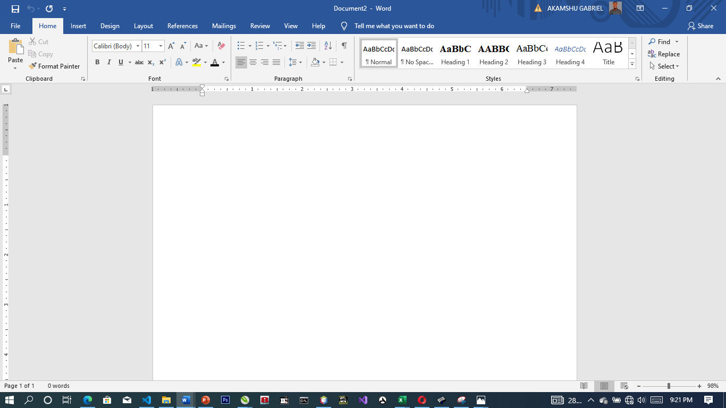

**Microsoft Word Viewed Screen.**

1. The title bar: wherever you saved any work, the file name and reside on the title bar
2. The menu bar: menu bar is made up of (file, edit, view, insert, format, tools, table, and window help).
3. The standard tool bar: consist of spelling and grammar icon, help.
4. The formatting tools bar: contain **(Bold (B), *(I), Italic* underline (U).**
5. **The drawing tools bar:** consist of any thin like auto shape, square, circle, text, word art pie chart, and bar chart etc.
6. **The insertion point:** or cursor is a place where you can insert table, row column etc.
7. **The ruler:** rule is mean for adjusting the MS-word environment etc.

**CONTROL SHORTCUT KEYS**

Ctrl + C: Copy selected text or object.

Ctrl + X: Cut selected text or object.

Ctrl + V: Paste copied or cut text or object.

Ctrl + A: Select all text in the document.

Ctrl + B: Bold selected text.

Ctrl + I: Italicize selected text.

Ctrl + U: Underline selected text.

Ctrl + Z: Undo the last action.

Ctrl + Y: Redo the last undone action.

Ctrl + F: Open the "Find and Replace" dialog box.

Ctrl + S: Save the current document.

Ctrl + P: Print the current document.

Ctrl + N: Create a new, blank document.

Ctrl + O: Open an existing document.

Ctrl + F1: Show or hide the Ribbon.

Ctrl + F4: Close the active window or document.

Ctrl + F5: Restore the size of the active window.

Ctrl + F6: Switch between open Word documents.

Ctrl + F9: Insert an empty field.

Ctrl + F12: Open the "Save As" dialog box.

**3.4 INTRODUCTION TO MS ACCESS**

Microsoft Access is a Database Management System (DBMS) from Microsoft that combines the relational Microsoft Jet Database Engine with a graphical user interface and software development tools. It is a member of the Microsoft Office suite of applications, included in the professional and higher editions.

1. Microsoft Access is just one part of Microsoft’s overall data management product strategy.
2. It stores data in its own format based on the Access Jet Database Engine.
3. Like relational databases, Microsoft Access also allows you to link related information easily. For example, customer and order data. However, Access 2013 also complements other database products because it has several powerful connectivity features.
4. It can also import or link directly to data stored in other applications and databases.

**HOW TO USE MS ACCESS**

Microsoft Access stores information which is called a database. To use MS Access, you will need to follow these four steps:

1. **Database Creation** - Create your Microsoft Access database and specify what kind of data you will be storing.
2. **Data Input** - After your database is created, the data of every business day can be entered into the Access database.
3. **Query** - This is a fancy term to basically describe the process of retrieving information from the database.
4. **Report** (optional) - Information from the database is organized in a nice presentation that can be printed in an Access Report.

**Creating a Database**

1. Start **Access**
2. Click on **Blank desktop database**

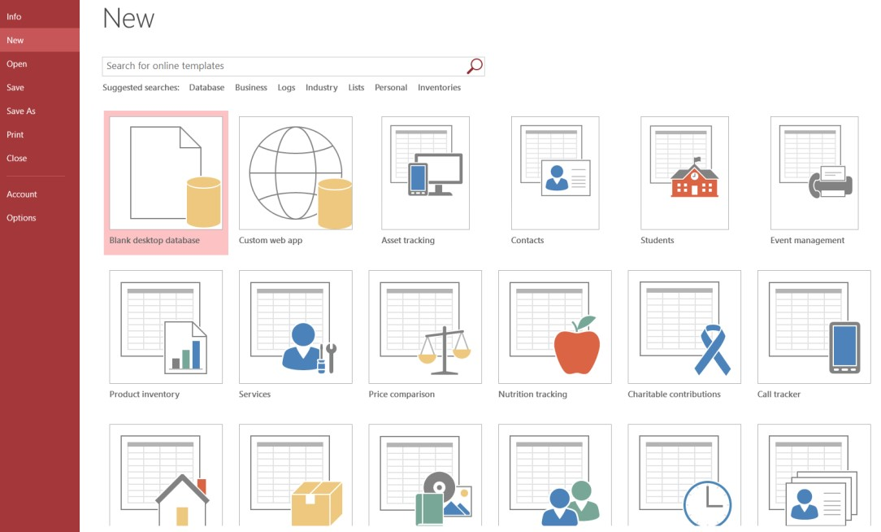

1. Under **File Name** type a name for the database
2. To change the location of where to store the database, click the folder icon and select a location
3. Click **Create**

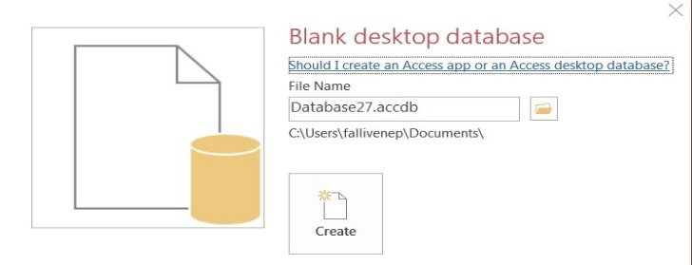

**To Save the Table:**

1. Click the **Save** icon on the toolbar
2. Enter a name for the table if you haven’t done so already
3. 3. Click **OK**

**Entering Data in a Table:**

1. In **Datasheet View**, start typing the data into the table by pressing the tab key to move to the next cell
2. When you have completed the record (row), press **Enter**
3. You can also click on the **New record** icon on the **Home** tab in the **Records** group

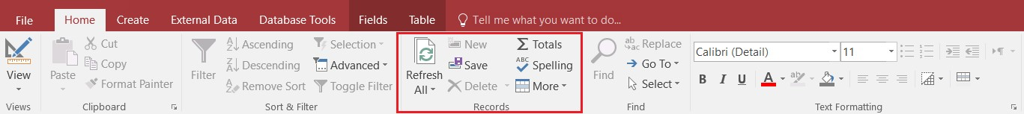

**Navigating in a Table:**

Use the arrows at the bottom of the table to navigate among records.



**Sorting Records in a Table:**

1. Position your cursor in the field that you wish to sort by clicking on any record in the table
2. Click either the **Sort Ascending** or **Sort Descending** icon on the **Home** tab in the **Sort & Filter** group

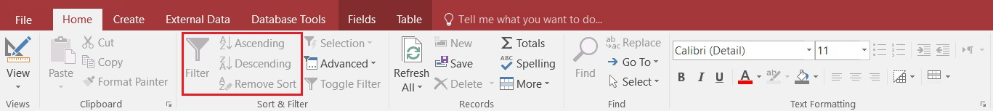

**Queries:**

You use queries to view, change, and analyze data in different ways. You can also use them as a source of records for forms and reports.

**To Create a Query:**

1. Click on the **Create** tab
2. Click on **Query Design** in the **Queries** group
3. Select the table that you would like to base your query on
4. Click **Add**
5. Repeat steps 3 and 4 until all tables are added
6. Close the Show Table window. The table(s) will now be displayed in the upper part of the **Query Design Screen** by boxes containing the tables’ fields.
7. **Double-click** on the field names in the field list window which you would like to include in the query

**Defining Criteria in the Query**

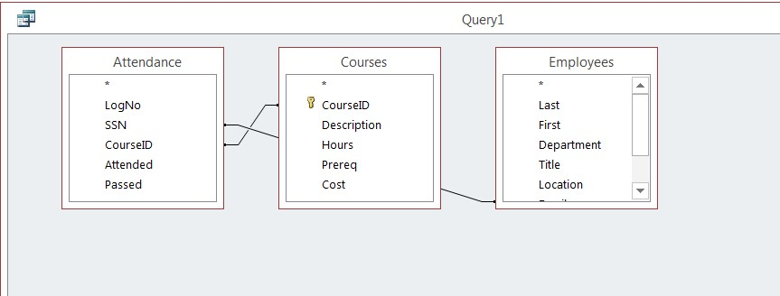

In order to control which records are displayed, you must define criteria in a query. The most common type of query is the **Select Records** query which will be discussed below.

**To Define Criteria for Your Query:**

1. Position your cursor in the criteria row in the field for which you wish to define the criteria for
2. **Type** the criteria. Example: To find all Excel courses:
3. Position your cursor in the criteria row of the **Course ID** field
4. **Type** Excel (Access adds the quote marks to the criteria automatically when you tab to the next column)

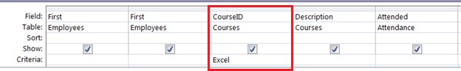

1. Click the **Run Query** button 

**To Save the Query:**

1. Click the **Save** icon
2. Enter a name for the query
3. Click **OK**

**MS ACCESS DATA TYPES**

|  |  |  |
| --- | --- | --- |
| **Type of Data** | **Description** | **Size** |
| **Short Text** | Text or combinations of text and numbers, including numbers that do not require calculating (e.g. phone numbers). | Up to 255 characters. |
| **Long Text** | Lengthy text or combinations of text and numbers. | Up to 63, 999 characters. |
| **Number** | Numeric data used in mathematical calculations. | 1, 2, 4, or 8 bytes (16 bytes if set to Replication ID). |
| **Date/Time** | Date and time values for the years 100 through 9999. | 8 bytes. |
| **Currency** | Currency values and numeric data used in mathematical calculations involving data with one to four decimal places. | 8 bytes. |
| **AutoNumber** | A unique sequential (incremented by 1) number or random number assigned by Microsoft Access whenever a new record is added to a table. | 4 bytes (16 bytes if set to Replication ID). |
| **Yes/No** | Yes and No values and fields that contain only one of two values (Yes/No, True/False, or On/Off). | 1 bit. |

**CREATE A TABLE IN DESIGN VIEW**

**To Create a Table in Design View:**

1. Click on the **Create** tab
2. Click on **Table**
3. Switch over to **Design View** on the **Home** tab
4. If prompted to save the table, enter a name and click on **OK**
5. Type the field names and select the appropriate data type for each field
6. Continue until all fields are added

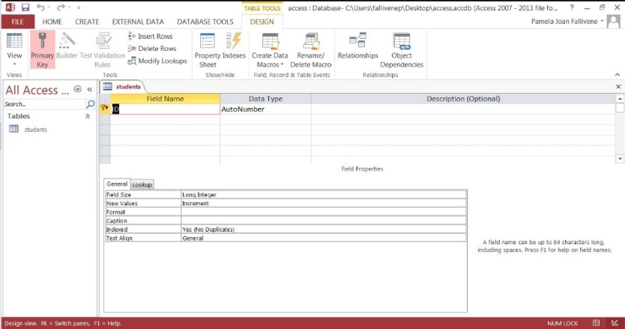

**CHAPTER FOUR**

**SUMMARY, CONCLUSION, PROBLEMS AND RECOMMENDATIONS**

# 4.1 SUMMARY

The relevance of the SIWES program cannot be over emphasized considering the fact that it has significantly reduced the gap between my theoretical and practical knowledge about computer hardware and software, installations, maintenance and networking. The processes of communication which include data and telecommunication the use of switch in the networking and what networking is all about.

The program is indeed a commendable one in that it affords students ample opportunities of being exposed to good working relationship with colleagues and the field experience with customers. This little exposure has widened my knowledge about my course of study, not only that it has automatically changed my views about lift in general. The firm at large has taught me how to be independent of my own how to be conscious of my health and safety at its peak relating to the environment where I carried out my SIWES program. It was indeed a highly rewarding experience to be with Excellence Computers, Obudu, Cross River State.

**4.2 CONCLUSION**

In conclusion, I thank ITF in general for their effort towards the Student Industrial Training Scheme. The contribution that the industrial training offered to student will not be over emphasized. It has exposed me seriously to a certain depth and length of practical capability on Computer Knowledge and practical know-how.

It has also acquainted me with the working condition, which I am expected to encounter in the near future. I will say that SIWES has a greater advantage on me, it has greatly exposed me to the practical application of all that I have been through in the school, SIWES is an experience that all student must pass through this is because it gives a full practical knowledge of what has been through in classroom.

Finally, I have a strong believe that this comprehensive based on the experience, I acquired during the industrial training scheme will convince every user training is not difficult.

I therefore strong conclude that the continuous existence of SIWES programme as it is very necessary since it plays a dominant role in the development of student of Computer Science in the acquisition of practical experience.

# 4.3 PROBLEMS OBSERVED DURING MY PROGRAM

1. The time frame set for the program is too short as some of the aspects of the program where not completed.
2. Lack of Financial support from the company to aid transportation to and from training.
3. Attentions are not given to the IT students by the workers it is learn if you want to learn or ask if you want to know.
4. Cost of Training: The Student has to be registered as a student of a particular organization in order to carry out the program.

**4.4 RECOMMENDATIONS**

Below are the recommendations that should be given serious consideration so as alleviate the suffering of students undergoing SIWES.

Firstly, the Federal Government of Nigerian should make a positive effort in reducing the overall cost of production so that companies should be producing to fill capacity and accommodate SIWES populaces. Also, certain monthly allowance may be given to the student by company accepted then (student to ease transportation problem).

Secondly, the Industrial Training Fund (ITF), should try and increase the money paid at the end of SIWES to the student so as to justify the Cost of Living we experienced.

Finally, the ITF official should please continue visiting the students, to ensure that what they are learning is in line with the ITF requirement.

**REFERENCES**

Edward, B. M.D (2003). The Effect of SIWES on a student, Federal Ministry of Works, Lagos. Nigeria.

Lowenthal, R. (2009).[*Improving the Design of PowerPoint Presentations*](http://www.ucdenver.edu/academics/CUOnline/FacultySupport/Handbook/Documents/Chapter_12.pdf). University of Colorado Denver.